RESUME
UNNIKUTTAN A U
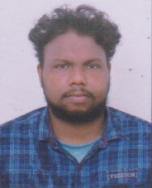

Contact No: 9961531349
Email.Id: unniau08@gmail.com

OBJECTIVE

To work on a challenging job profile which provides an opportunity to enhance my skills and knowledge, and develop my communication and interpersonal skills.
PERSONAL PROFILE
Name : UNNIKUTTAN A U
Father’s Name : Udhayan B
Date of Birth : 31-01-2000
Sex : Male
Marital Status : Single
Nationality : Indian
Religion : Hindu Cheramar
Languages Known : English, Malayalam
Permanent Address : Unni Nivas
Manarcad P O
Kottayam – 686019
Kerala

ACADEMIC QUALIFICATIONS
T H S L C 2015 in Technical H S Pampady (Fitter)
V H S E C 2018 in V H S C Pampady (Polymer Technology)

Training : A certificate from Common Facility Service Centre, Changanassery Kottayam in Ploymer Technology Service.

CONCLUSION AND DECLARATION
I here by declare that the above furnished information are true and correct to the best of Knowledge and belief. If selected I assured that I would perform the best of my abilities exemplary professional approach to reach up to the organizations expectation eagerly awaiting a positive response.

Thanking You

Place : Manarcad UNNIKUTTAN A U
Date :

